Fusible Link

At Carlisle I spoke with 2 members that had experienced burned wiring in their C1s. While we are not certain just what caused their problems, there was a very nice, and appropriate, article by John Hinckley in the October 2005 issue of Corvette Enthusiast. It was John’s conclusion that the short which results in burned wiring can often be traced to the ignition shielding. If the coil is not oriented properly, the 12 volt lead to the positive (+) terminal on the coil can come into contact with the shield resulting in a direct short to ground and burned wiring or a car fire.

Prior to ’67 (which pretty much means all our cars) the ignition circuit was not protected by a fuse of any type – agreed, there were fuses for certain items within or on the car but nothing protected the main circuit at all. Beginning in 1967, all Corvettes came with a fusible link protecting the wiring system. A fusible link is nothing more than a type of fuse comprised of fine wire designed to burn through in the event of a short. If the ignition circuit is fed with a 12 gauge wire you use a 4 number smaller fusible link – in this case, a 16 gauge fusible link. A 10 gauge feed would take a 14 gauge fusible link, etc.

For your own protection and the safety of your car – I’ve looked at burned cars before and it is not a pretty sight – you might want to consider adding a fusible link to your wiring system. Our systems are fed from the large bolt on the starter solenoid through, probably, a 12 gauge black wire. Merely disconnect that wire and splice the appropriate sized fusible link between the large bolt and the wire you removed from the bolt.
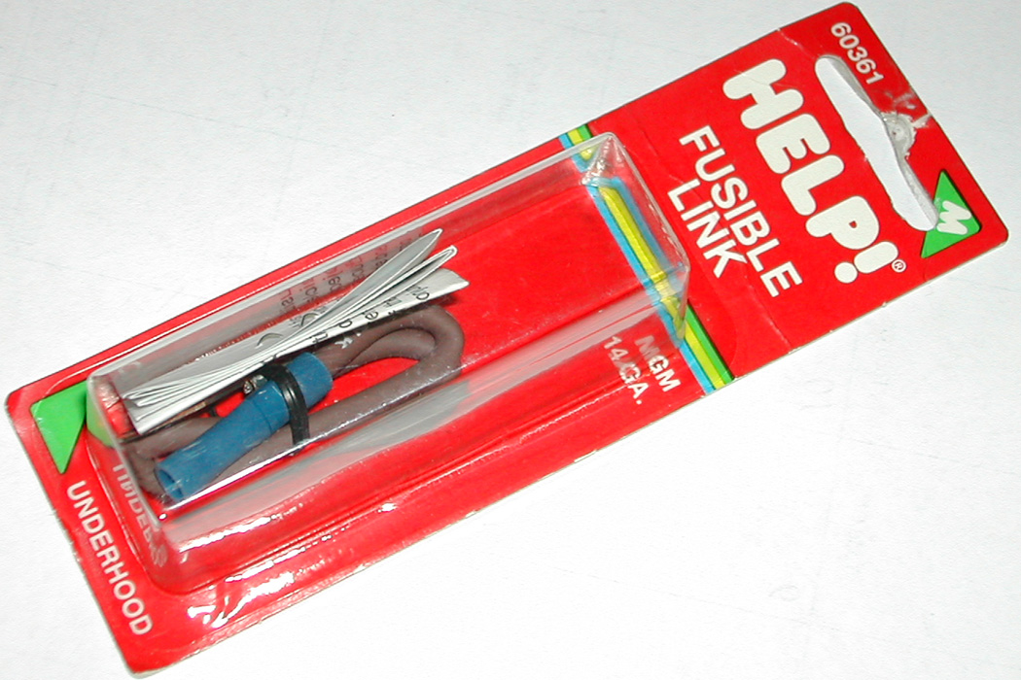
Fusible links are available at all auto part stores as well as your local Chevrolet parts shop for about $4. For those of you with sharp eyes, this is a 14 gauge fusible link for my truck, a spare I had around the garage – this would be too big for most of our C1s as a 16 gauge link would be more appropriate. I bought this at “Advance Auto” and they had the right 16 gauge size – I believe labeled as a Ford or Chrysler part.

Oh, and by the way – while you are busy installing your new fusible link – pull your ignition shield off and check to make certain that the coil is oriented in such a way as to prevent an accidental short of the positive terminal to the shielding. Later Corvette models have a plastic insulator glued to the inside of the shield to prevent such accidental shorts – which seems like a pretty good idea to me.

